Market Monitor - Afghanistan - 2026-06

Highlights
In June 2026, the cost of essential food items in Afghanistan decreased month-on-month, providing some short-term relief to consumers. However, prices remain significantly elevated compared to the previous year, continuing to impact household purchasing power.
The cost of the standard food basket decreased by 3.4% from the previous month but remains 28.9% higher than in June 2025. This monthly decrease was primarily driven by falling prices for key staples, including Wheat (↓4.2%), Sugar (↓3.5%), and high-quality Rice (↓3.3%).
Key Drivers:
- A month-on-month decrease in the cost of the standard food basket (↓3.4%), led by price reductions in essential commodities like Wheat (↓4.2%) and high-quality Rice (↓3.3%).
- Persistently high year-on-year prices, with the food basket costing 28.9% more than in the previous year.
- Significant annual price inflation in major commodities, including high-quality Rice (↑30.9%) and Sugar (↑23.8%), which continue to strain household budgets despite the recent monthly price drop.
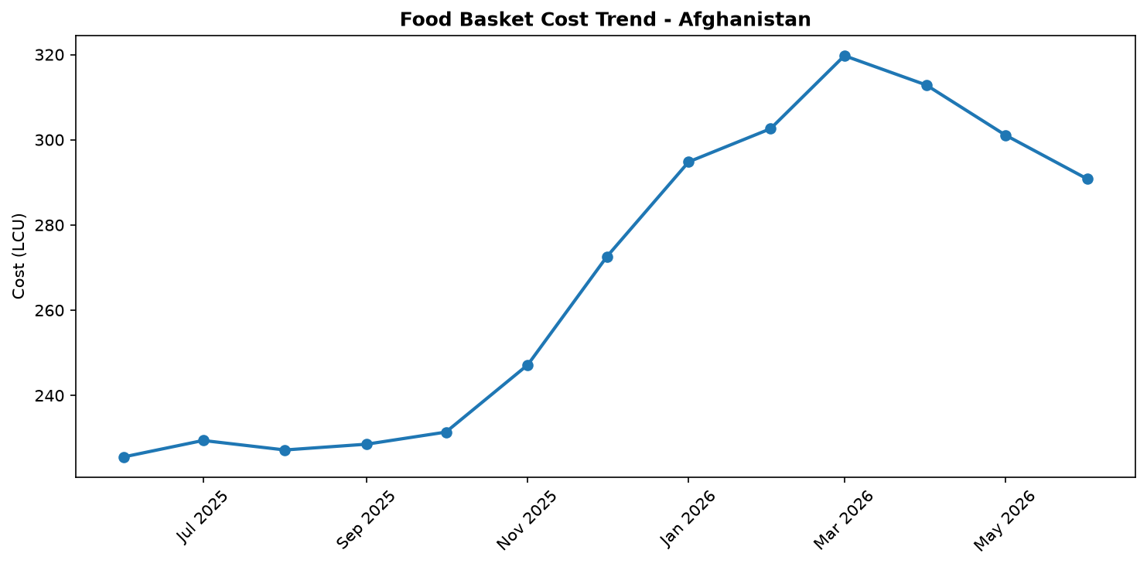
Food basket cost trend

Market Overview
In June 2026, Afghan markets experienced a short-term reprieve as the cost of the standard food basket decreased by 3.4% month-on-month. This decline was primarily driven by price reductions in key staples, including high-quality rice (-3.3%) and wheat (-4.2%). However, this recent relief is overshadowed by severe long-term price pressures, with the food basket remaining 28.9% more expensive than in the previous year. The market environment is shaped by several competing factors. On one hand, the stability of the Afghani currency, which averaged AFN 63.9/USD in May, has helped mitigate further price volatility. On the other hand, significant demand-side pressure persists due to the influx of over 6 million returnees from Pakistan and Iran since late 2023. Compounding this, ongoing regional trade disruptions continue to reshape import patterns, while humanitarian funding shortfalls threaten the response capacity for widespread economic hardship. The current downward price trend may prove temporary, as underlying inflationary pressures and emerging climate risks, such as a developing El Niño event, signal continued volatility in the months ahead.

Commodity Analysis
An analysis of individual commodity prices reveals a widespread, though potentially temporary, monthly decrease across most essential food items. The price of high-quality rice, a key staple, fell by 3.3% from the previous month, contributing significantly to the overall reduction in the food basket cost. Despite this, it remains a primary driver of annual inflation, with its price a staggering 30.9% higher than one year ago. Wheat prices saw an even more pronounced monthly drop of 4.2%, though its year-on-year increase of 11.9% is less severe. Sugar prices followed a similar trend, decreasing by 3.5% month-on-month while remaining 23.8% more expensive than last year. Cooking oil demonstrated relative stability, with a modest 2.0% monthly decrease and only a 2.7% year-on-year increase, indicating it is not a significant factor in the current high-inflation environment. Salt was the sole monitored commodity to register a price increase this month, rising by 1.6% and standing 10.0% higher than the previous year. This data underscores a consistent theme: while monthly prices for most staples have fallen, their annual costs remain exceptionally high, straining household purchasing power.
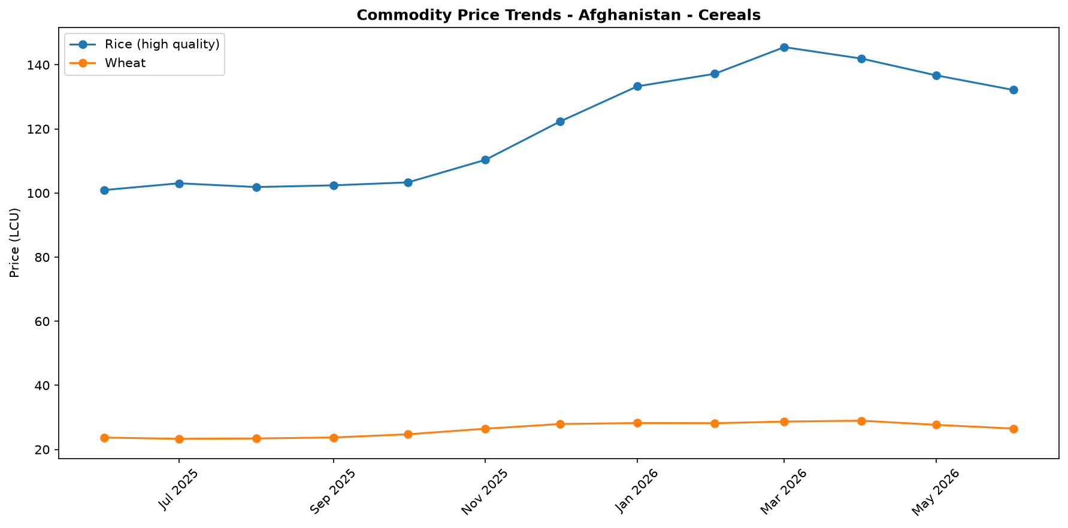
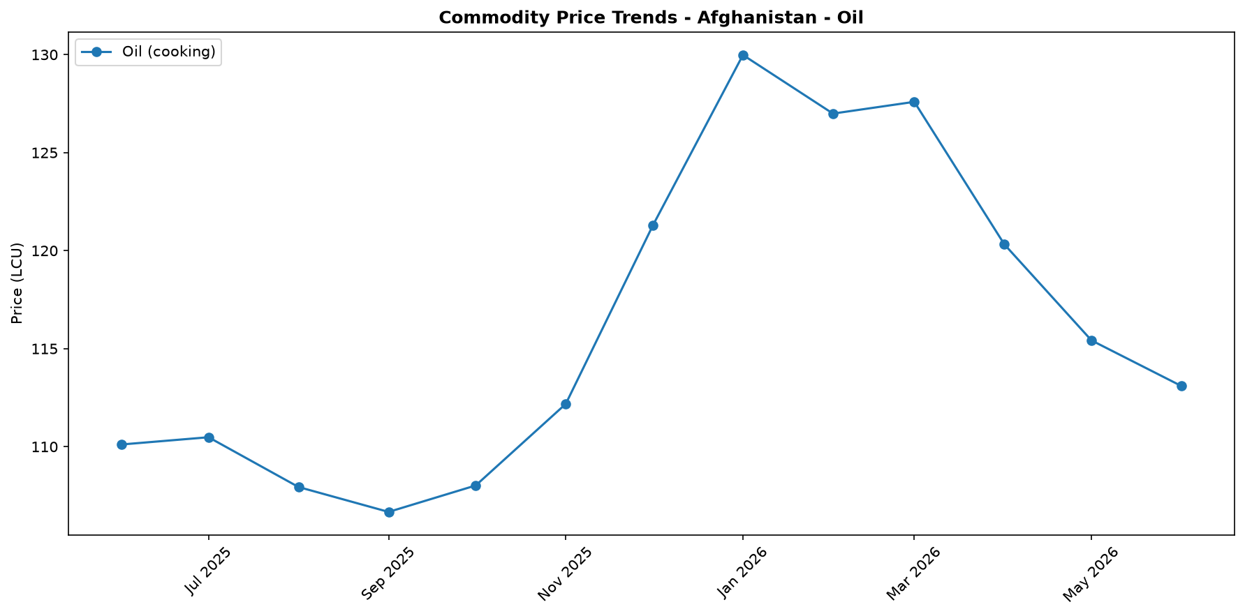
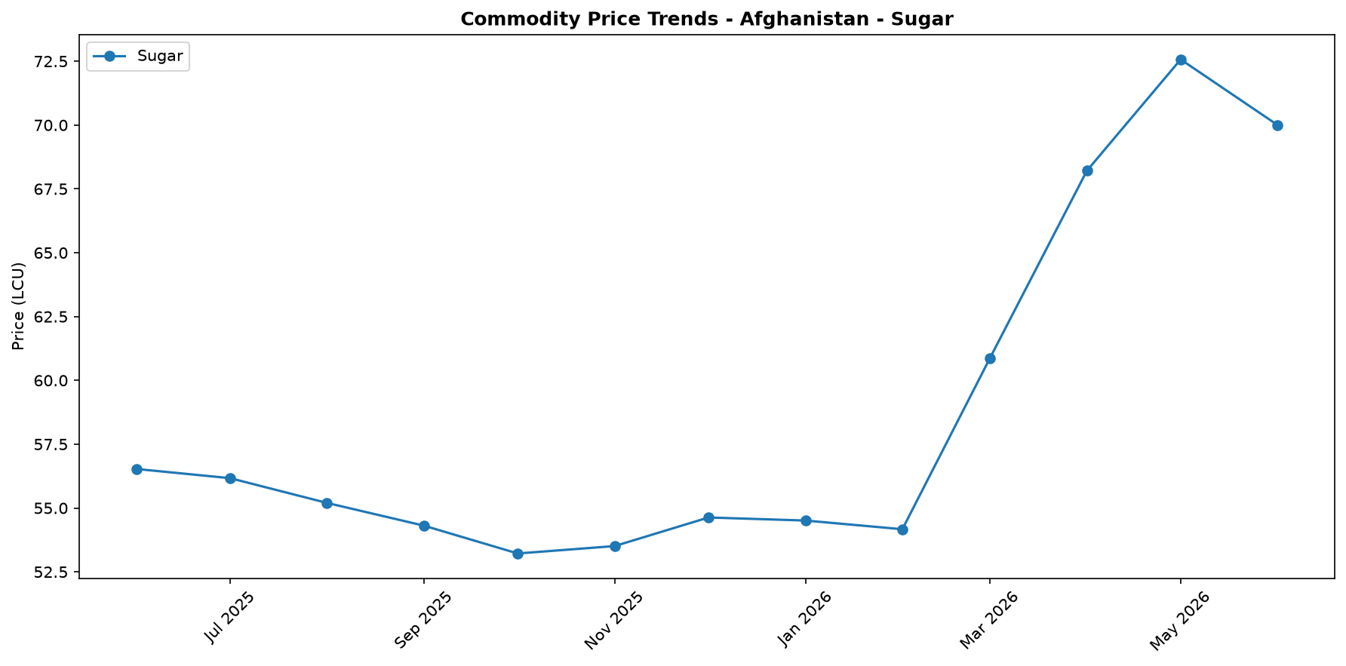
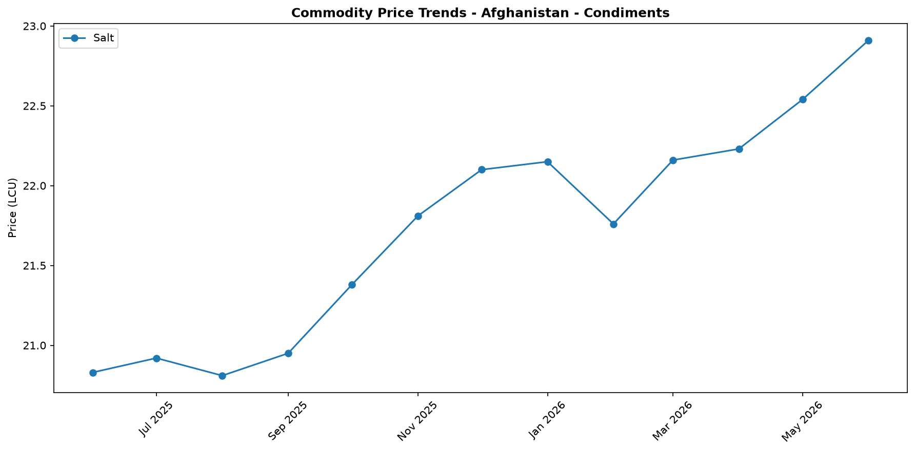

Regional Highlights
Nationally, the market in Afghanistan is characterized by a dual trend: a welcome 3.4% monthly decrease in the cost of the food basket, which offers some immediate relief to consumers, set against a stark 28.9% year-on-year price increase. This sustained high-cost environment is influenced by factors impacting the entire country. The large-scale return of approximately 6.04 million Afghans has significantly increased demand for food and essential goods across all regions. Simultaneously, ongoing trade disruptions have necessitated the use of alternative import corridors, affecting supply and pricing nationwide. While the stable Afghani currency provides a degree of macroeconomic insulation against more extreme price shocks, significant pressures remain. Although the national average shows a decrease, price levels and volatility can vary between regions due to localized supply chain efficiencies, security, and access.
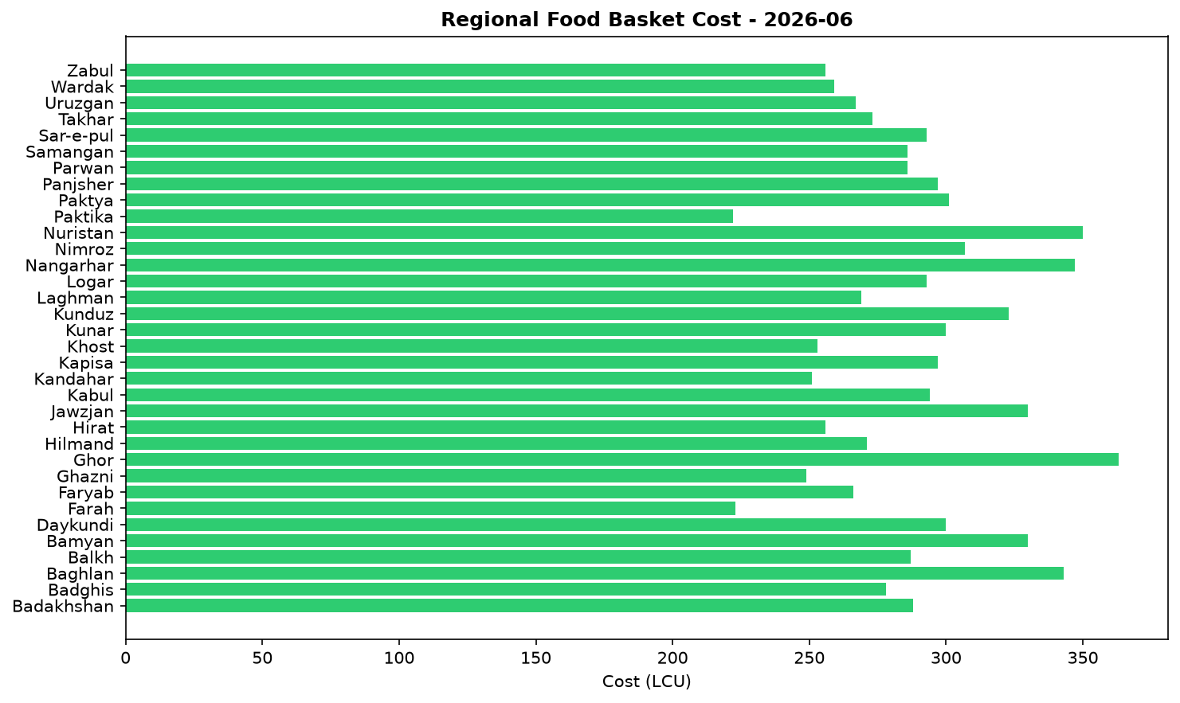
These underlying factors suggest that despite the recent dip, the risk of price increases remains high across the country.

References
- [rw_4216543] ReliefWeb (2026-06-17) Asia and the Pacific: Snapshot of El Niño & Middle East Crisis (as of 12 June 2026)
https://reliefweb.int/node/4216543
- [rw_4216537] ReliefWeb (2026-06-17) Afghanistan: Monthly Market Report Issue 72: May 2026
https://reliefweb.int/node/4216537
- [rw_4216434] ReliefWeb (2026-06-16) Afghanistan — Returnee Resilience Overview (Round 2, June 2026)
https://reliefweb.int/node/4216434
- [rw_4216401] ReliefWeb (2026-06-16) Afghanistan: Humanitarian Update, May 2026
https://reliefweb.int/node/4216401
- [rw_4216245] ReliefWeb (2026-06-15) Concern reached 23 million people in 27 countries last year
https://reliefweb.int/node/4216245
- [rw_4216224] ReliefWeb (2026-06-15) Asia-Pacific Gender Based Violence in Emergencies Update – Q2 2026 (Special Release for El Niño)
https://reliefweb.int/node/4216224
- [rw_4216187] ReliefWeb (2026-06-15) Afghanistan: Weekly Market Report: Issue 299: Week 2 – June 2026
https://reliefweb.int/node/4216187
- [rw_4216176] ReliefWeb (2026-06-15) Data for Afghanistan: Latest Poverty Lines by Afghanistan Provinces, April 2026
https://reliefweb.int/node/4216176
- [rw_4215895] ReliefWeb (2026-06-11) Escalation in the Middle East and Beyond — Mobility Report (03 - 08 June 2026)
https://reliefweb.int/node/4215895
- [rw_4215837] ReliefWeb (2026-06-11) Iran-Afghanistan - Returns Emergency Response #30 (as of 6 June 2026)
https://reliefweb.int/node/4215837
- [seerist_1028928] Seerist (2026-06-10) Military co-operation between Taliban, Russia unlikely to significantly boost Taliban’s capabilities
- [seerist_1028903] Seerist (2026-06-09) Sovereign risk remains EXTREME despite improvement in tax revenues
- [seerist_1028629] Seerist (2026-05-20) New law on distribution of state land underscores EXTREME regulatory risk
- [seerist_1028557] Seerist (2026-05-15) Clashes over gold mine, Taliban’s poppy destruction policy underscore EXTREME security risk
- [seerist_1028494] Seerist (2026-05-12) Uptick in Pakistan-Afghan Taliban hostilities likely following complex attack in Khyber Pakhtunkhwa

